REACT is a frontend JavaScript library for building user interfaces.

Developed by FACEBOOK. Maintained by FACEBOOK and open source contributors.

React uses something called Virtual DOM -

Virtual DOM - JavaScript object

Faster than real DOM

Components - based frontend library

Pages are divided into components

Components let you split the UI in the independent, reusable parts.

First, we start with building components independently and then connect them to form a complete UI.

Two types of components-

1. Functional
2. Class-based

Types of function we can write in a component: Normal function, Arrow Function, Named Function

Class-based components(Not used anymore) Functional components (Arrow function used)

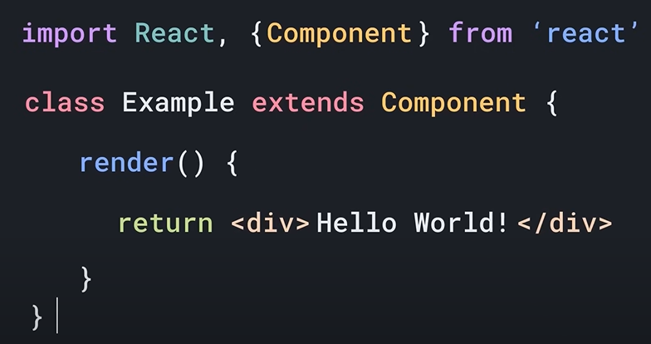 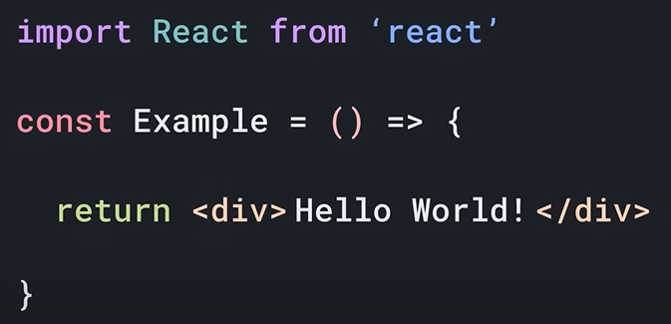

* JSX Syntax used.

What is JSX?

JSX is a JavaScript Extension Syntax used in React to easily write HTML and JavaScript together.

React Environment Setup

1. Manually setting up all the things using webpack and babel.
2. Using the create-react-app command.

We had to use className because class is a reserved keyword in JavaScript

* Put valid JavaScript in the curly braces.

If you want to render 2 different elements one next to another, you need to wrap in the react fragment <></>

Components – create many different components and then import them into large components.

Props – props allow you to pass dynamic data through react components. They are just arguments that you pass in the react components.

State – in react is a plain JavaScript object used by react to represent a piece of information about the component’s current situation. It is completely managed by the component itself.

* useState hook from React

Whenever you call something as a function, and it starts with “use”, in react, we call that a “Hook”.

Counter, setCounter = useState(0);

[name of the state, setter function

Setter function generally has the same name, just add “set” in front. Because it is a set function for the first variable.

Inside of the useState(), we provide the initial value.

Event – an event is an action that can be triggered as a result of the user action or some kind of a system generated event. (example - mouse click, button press)

* update things without the need of a page reload.

useEffect – allows us to do something on some kind of an effect, or some kind of an event.

REMEMBER – Never modify the state manually. React state can only be changed using its own setter function.